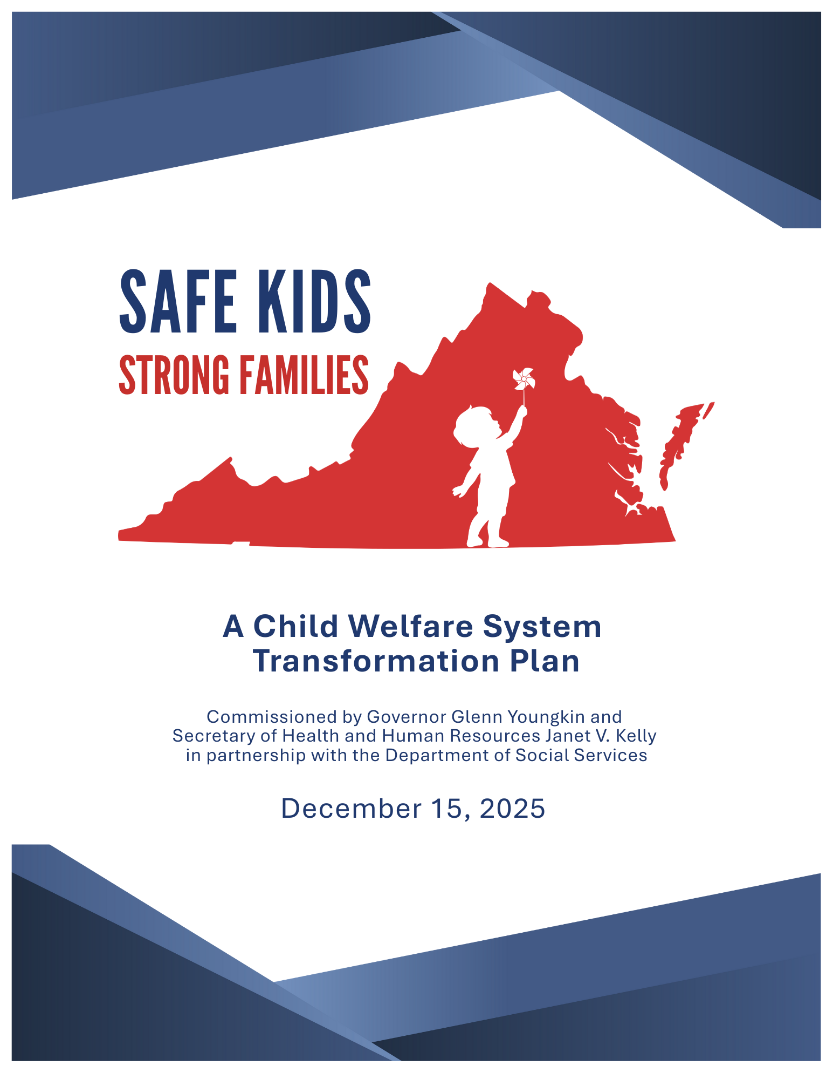
Contents
Executive Summary i
Pillar 1. Strengthening the Workforce ii
Pillar 2. Child Protective Services (CPS) ii
Pillar 3. Permanency for Youth iii
Pillar 4. Behavioral Health and Child Welfare iii
Pillar 5. Prevention and Family Preservation iii
Pillar 6. Modernization of Oversight and Infrastructure iii
SKSF Initiative Overview 1
Phase I – Diagnostic (May–June): 1
Phase II – Strategy Design (June–July): 2
Phase III – Sharing and Refinement (July–August): 2
Themes Emerged through Stakeholder Engagement 3
Safety as the Priority 3
Accountability Tools Needed 3
Workforce Challenges 4
Vision for Virginia’s Child Welfare System 5
Safe Kids, Strong Families: Pillars and Initiatives 7
Pillar 1: Strengthening the Workforce 7
Pillar 2: Child Protective Services (Safety) 11
Pillar 3: Permanency for Youth 14
Pillar 4: Behavioral Health 17
Pillar 5: Prevention and Family Preservation 19
Pillar 6: Modernization of Oversight and Infrastructure 22
Summary of Pillars and Initiatives 29
Initiatives Prioritized by Steering Committee 30
#1: Create a Statewide Accountability Framework (Pillar 6: Modernization of Oversight and Infrastructure) 30
#2: Centralize Intake and Screening of Child Welfare Referrals (Pillar 2: Child Protective Services) 31
#3: Provide Competitive Compensation (Pillar 1: Strengthening the Workforce) 33

Executive Summary
Virginia’s child welfare system stands at a pivotal moment. On May 15, 2024, Governor Glenn Youngkin launched the Safe Kids, Strong Families initiative to advance Virginia's child welfare reforms. It included funding a $1 million study to provide a stakeholder-informed, evidence-based roadmap to address challenges in the child welfare system and build a stronger, safer future for children and families. Over the course of four months, under the leadership of the Virginia Department of Social Services (VDSS), and in partnership with Local Departments of Social Services (LDSS), community organizations, and other state agencies, the project team engaged 280+ stakeholders in intensive workshops, design sessions, and direct interviews. These stakeholders brought diverse perspectives from across the child welfare system, including from VDSS, LDSS, community partners, and individuals with lived experience.
The Safe Kids, Strong Families initiative and report were conducted after 3 significant efforts related to child welfare during the Youngkin administration.
- Year One, then-Special Advisor for Children and Families Janet Kelly led the Safe and Sound Task Force which reduced the number of kids sleeping in DSS offices, ERs and hotel by 89% in 90 days.
- Year Two, the Administration fully began the implementation process of the Right Help, Right Now behavioral health transformation plan. Given the large percentage of children placed in foster care due to a parent’s substance use disorder or mental illness, Right Help, Right Now is a foundational initiative to Safe Kids, Strong Families.
- Year Three, the Youngkin Administration worked in a bi-partisan fashion with the Virginia General Assembly to develop and fund a first of its kind kinship program that provides financial support to extended family and friends who take custody of children to keep them safe and out of foster care.
In addition, a landscape analysis of more than 27 states was conducted to identify innovations and best practices in child welfare. This landscape analysis included states, similar to Virginia, with state-supervised, locally administered child welfare systems. Furthermore, extensive data analysis was conducted on over 50 datasets and reports.
This intentional collaboration produced a three-year child welfare strategy that directly responds to gaps in child safety, workforce, accountability, permanency, and access to prevention and behavioral health services.
Project governance was anchored by a Steering Committee, including the Secretary of Health and Human Resources, Commissioners and Directors from key state agencies, leadership from VDSS, and a Core Team, comprised of League of Social Service Executives and VDSS program leadership.
The result is a three-year strategic roadmap (2025 – 2028) designed to improve outcomes for Virginia’s most vulnerable children and families. At its core is a transformation framework organized around six pillars, each addressing a critical dimension of the Commonwealth’s child welfare infrastructure:
- Strengthening the Workforce
- Child Protective Services
- Permanency for Youth
- Behavioral Health and Child Welfare
- Prevention and Family Preservation
- Modernization of Oversight and Infrastructure
The three-year timeline prioritizes high-impact changes in year one while laying the groundwork for longer-term reforms. By design, the SKSF roadmap reflects both the technical evidence from data and national scans as well as the lived experience of Virginia’s child welfare workforce, families, and community partners. Implementation will require sustained executive leadership, strong collaboration across state and local partners, and bold investment in the workforce and accountability mechanisms.
The Six Pillars of Transformation
Across the six pillars, 25 initiatives were identified. Many of the initiatives are innovations and best practices in child welfare that were identified as part of the landscape assessment of more than 27 states.
Concrete initiatives and sub-initiatives support each pillar. Each initiative, taken together, contributes to progress and to a system that is safer, more consistent, and more responsive to the needs of children and families.
Pillar 1. Strengthening the Workforce - Virginia’s child welfare professionals are its greatest asset. This strategy is designed to increase competitiveness and establish stronger employee retention:
- Provide competitive compensation by increasing base salaries of Family Services Specialists and supervisors in line with national and local labor market standards.
- Pilot broadened recruiting pipelines supported by VDSS from nontraditional fields (e.g., veterans) and early career pathways through community colleges and high schools.
- Expand professional development, including supervisor credentialing and guided coaching.
- Launch retention pilot that sets caseload targets, establishes career pathways, and uses staff feedback from both departing and long-tenured employees to reduce turnover and strengthen early-tenure retention.
- Enhance employee experience with wellness supports and advanced digital tools to increase efficiency.

Pillar 2. Child Protective Services (CPS) - This pillar ensures all children receive timely and equitable protection.
- Centralize intake and validity to support consistency of screening decisions across the Commonwealth.
- Improve safety for children under age 3 through a Code change to require 24-hour response and expand VDSS -hospital data-sharing.
- Leverage AI and advanced analytics to support human-led screening and assessments.
- Ensure timely assessments with new data-informed monitoring systems and technical assistance by practice consultants for underperforming LDSS.

Pillar 3. Permanency for Youth - This strategy supports both permanency and successful transitions to adulthood.
- Reduce use of congregate care by developing a program to recruit families caring for youth with complex needs and ensure support for families by stakeholders across the permanency ecosystem.
- Build upon efforts to support adoptive and guardianship families to reduce disruptions.
- Expand support system and services for youth aging out of care, including intensive case management, housing, employment, and mentoring.
- Enable safe reunification by revising reunification criteria and restoring access to disrupted benefits.

Pillar 4. Behavioral Health and Child Welfare - Behavioral health needs are often the root cause of system involvement.
- Coordinate with the Department of Medical Assistance Services (DMAS) and Medicaid managed care organizations to increase collaboration for youth in care.
- Prioritize support for parents with substance use disorders, including those with substance-exposed newborns.
- Provide preventive behavioral health care at the first point of contact and redefine what constitutes a crisis.
- Expand the Virginia Mental Health Access Program to child welfare professionals and prescribers of psychotropic medications.

Pillar 5. Prevention and Family Preservation - Keeping families together safely is a top priority.
- Increase federal funding drawdown (Title IV-E prevention funding) under the Family First Prevention Services Act (FFPSA) by building LDSS capacity and streamlining administrative processes.
- Establish community pathways to prevention services in every region, in collaboration with schools, hospitals, and nonprofits.
- Expand access to prevention services in each locality, including through virtual delivery in rural areas.

Pillar 6. Modernization of Oversight and Infrastructure - System improvement requires the right tools and governance.
- Create a statewide accountability framework to ensure quality and consistency throughout the Commonwealth.
- Modernize data systems via Comprehensive Child Welfare Information System (CCWIS) to streamline casework and increase interoperability.
- Improve transparency on abuses and fatalities contributing to stronger public trust and providing insight to inform training and policy decisions.
- Strengthen organizational structure and governance by clarifying roles between VDSS, regional offices, and LDSS.
- Build capacity-sharing models that allow case management to be distributed across CSA and contracted providers.
Implementation Timeline
The Safe Kids, Strong Families framework is designed to support local capacity, encourage partnership, and ensure that each step moves us closer to a safer future for Virginia’s children. The implementation timeline lays out a clear path to make this a reality, beginning in year one with the highest-impact priorities and laying the groundwork for broader reform in subsequent years.

SKSF Initiative Overview
VDSS and the project team structured the Safe Kids, Strong Families (SKSF) design process to include stakeholder engagement to inform the three-year strategic roadmap to improve outcomes for Virginia’s most vulnerable children and families. Project governance included a Steering Committee working in close partnership with a Core Team. The Steering Committee included the Secretary of Health and Human Resources, the Commissioner and Deputy Commissioner of VDSS, Commissioners and Directors from key sister state agencies, including the Department of Medical Assistance Services (DMAS), the Office of Children’s Services (OCS), and the Office of the Children’s Ombudsman (OCO). The Core Team, which included the League of Social Service Executives and VDSS program leadership, provided extensive feedback throughout the project.
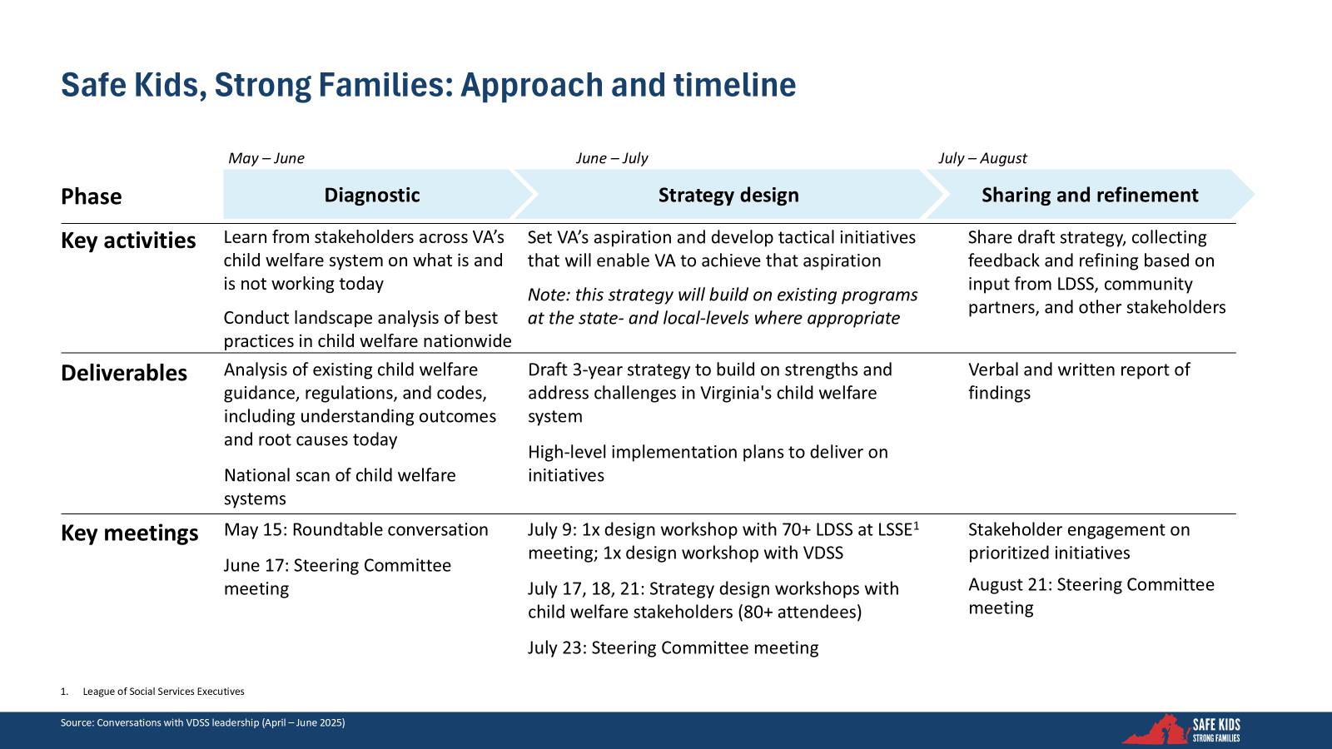

Phase I – Diagnostic (May–June):
The project began with a broad diagnostic effort to understand both the strengths and challenges of Virginia’s child welfare system. The team reviewed and analyzed more than 50 datasets and reports and conducted a landscape scan of more than 27 states, prioritizing those that are state-supervised and locally administered, so lessons would be directly relevant to the Commonwealth. In parallel, more than 80 Virginia stakeholders, including local departments of social services and community partners, participated in discussions to highlight what is and what is not working today. This stage produced a deep analysis of current outcomes, regulatory frameworks, and promising national practices.

Phase II – Strategy Design (June–July):
Building on the diagnostic findings and early stakeholder input, the project team convened five in-person and virtual design workshops with more than 150 participants representing local agencies, state leadership, and community partners, asking “What can Virginia do?” These sessions focused on generating over 100 initiative ideas and prioritizing initiatives that align with Virginia’s long-term goals for child welfare. From these workshops, the three-year strategy was developed, and implementation pathways were outlined that build on existing strengths and address pressing gaps.

Phase III – Sharing and Refinement (July–August):
In the final stage, the project team focused on engagement and refinement. They shared draft initiatives widely with more than 150 stakeholders, including LDSS staff, community organizations, and partner agencies, to gather feedback and sharpen the strategy. The team also conducted nine one-on-one interviews with select stakeholders to refine insights and clarify priorities. Through this collaborative process, the SKSF strategy reflects both the technical evidence from the diagnostic phase and the lived experience of those directly involved in child welfare.
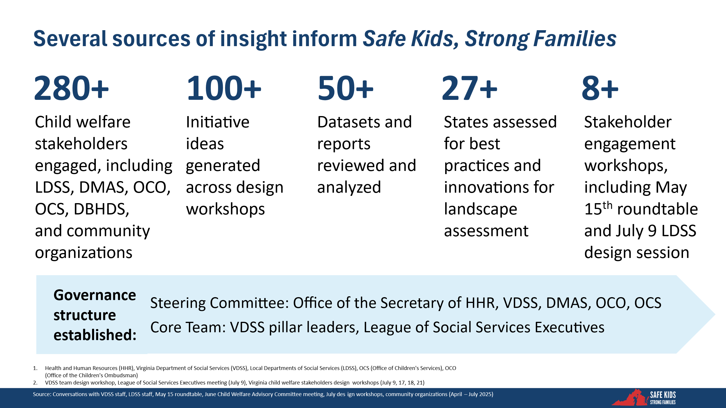

Themes Emerged Through Stakeholder Engagement
Important, consistent themes emerged during the stakeholder engagement process.

Safety as the Priority
Stakeholders consistently emphasized that child safety must be the foundation of Virginia’s child welfare system. As one participant reflected, “It’s the first time, in a very long time, the safety and welfare of children was actually central in the discussions about the system.” This renewed focus ensures that every decision, from policy to practice, is centered on protecting children and strengthening families.

Accountability Tools Needed
The second theme raised was the need for stronger accountability in Virginia’s state-supervised, locally administered system. Stakeholders noted that the responsibility placed on LDSS is substantial, and that “they need more state resources for support.” Others stressed that “the amount of variation between LDSSs today is hard to believe, there has to be a better way.” These concerns highlight the need to establish clear accountability frameworks to ensure consistent and equitable outcomes for children and youth across the Commonwealth.

Workforce Challenges
Finally, stakeholders underscored the critical importance of supporting the child welfare workforce. They described the reality that “you cannot expect people with lots of credentials and degrees to accept such a low salary and a job that is so challenging.” Recurring themes included concerns about high caseloads, limited training, and inadequate supervision. Addressing these workforce challenges is essential to building a sustainable system that delivers on its mission to keep children safe and families strong.

Vision for Virginia’s Child Welfare System
During the May 15 Stakeholder Roundtable, more than 80 participants considered the critical question: What is our vision for Virginia’s child welfare system over the next three years?
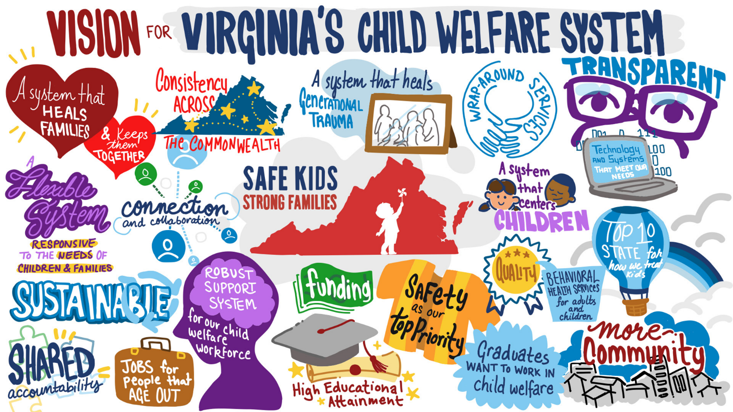
This exercise produced an illustration that reflects the priorities voiced in the room, focused on ensuring the system is sustainable, consistent, and capable of supporting children and families and helping them achieve positive outcomes. Stakeholders called for a system that keeps families together, promotes shared accountability across the Commonwealth, provides robust workforce support, operates with transparency, and offers flexible services responsive to the needs of children and families. Most importantly, participants emphasized that child safety must remain the top priority, while building a community-centered system that can break cycles of trauma for future generations.
To achieve the vision, VDSS identified both the current state and aspiration across six areas of focus. This helped to translate the vision for the child welfare system into concrete areas of focus.
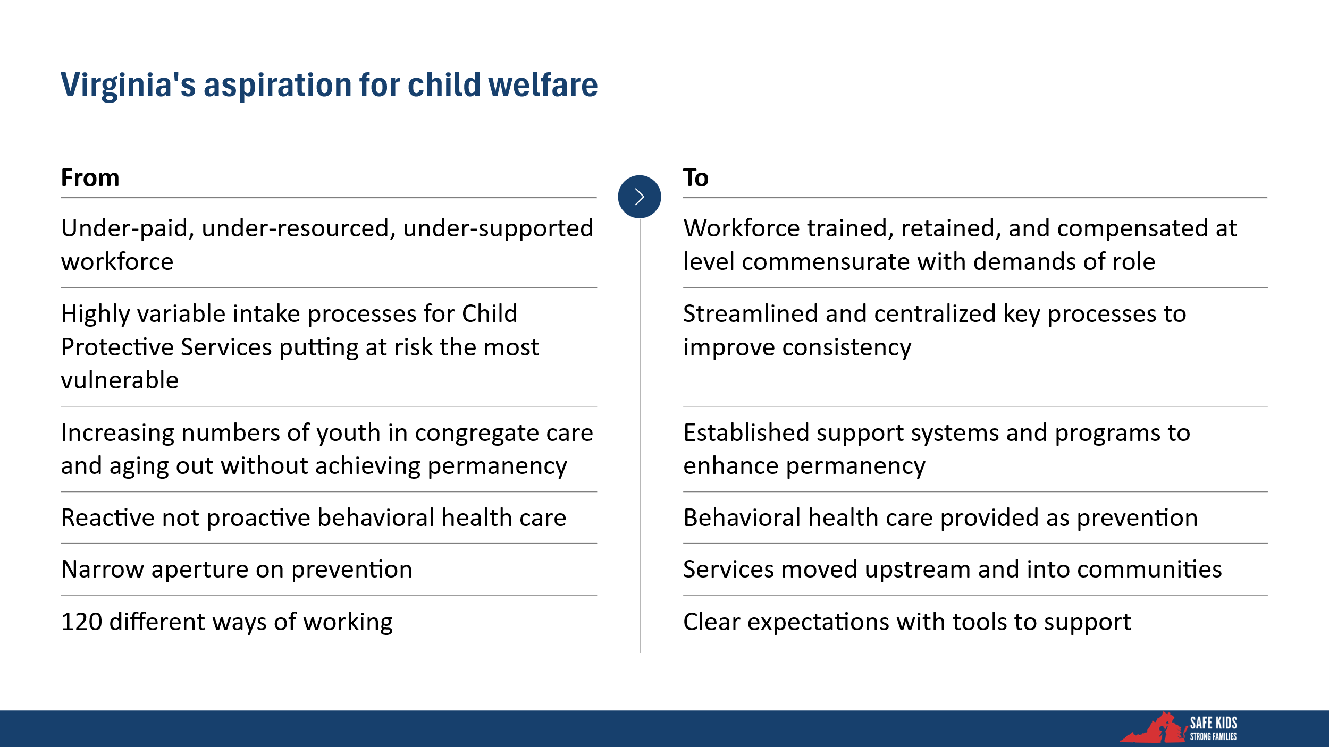

Safe Kids, Strong Families: Pillars and Initiatives
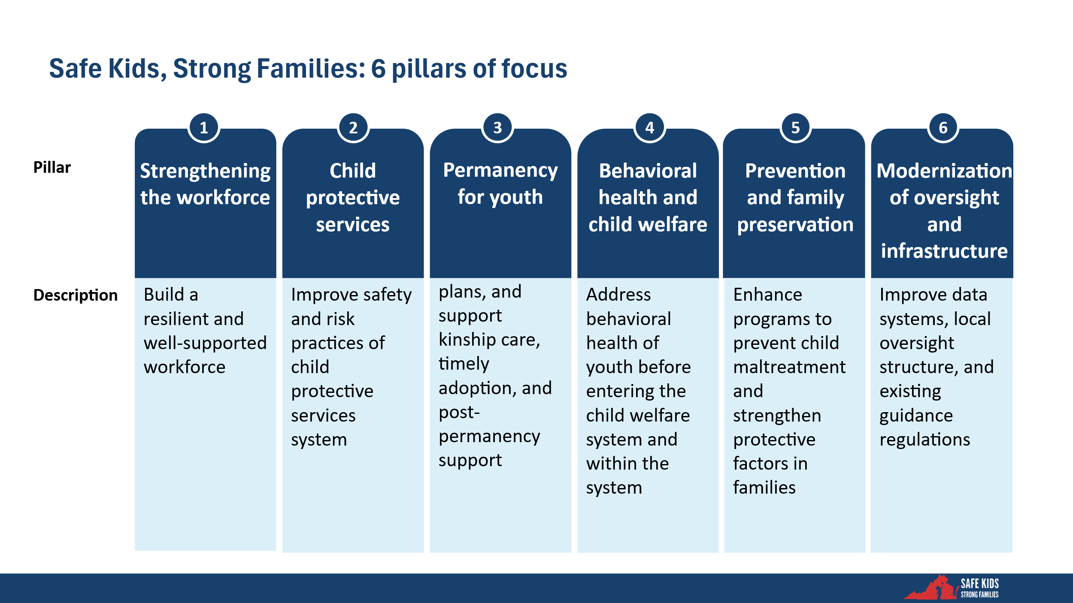

Pillar 1: Strengthening the Workforce
A strong and consistent child welfare workforce is foundational to the safety, stability, and well-being of vulnerable children and families. LDSS Family Services staff are often the primary point of contact for families engaged in the child welfare system. Their ability to build trust, make sound decisions, and coordinate timely interventions can directly influence outcomes such as family reunification, placement stability, and permanency.
A skilled and supported workforce helps ensure that policies and programs are implemented as intended. When workers are overburdened, underpaid, and not consistently or adequately trained, the quality and consistency of service suffer. This creates disparities across the Commonwealth and diminishes public trust in the child welfare system. Investing in workforce capacity is a vital strategy for strengthening the overall child welfare system.
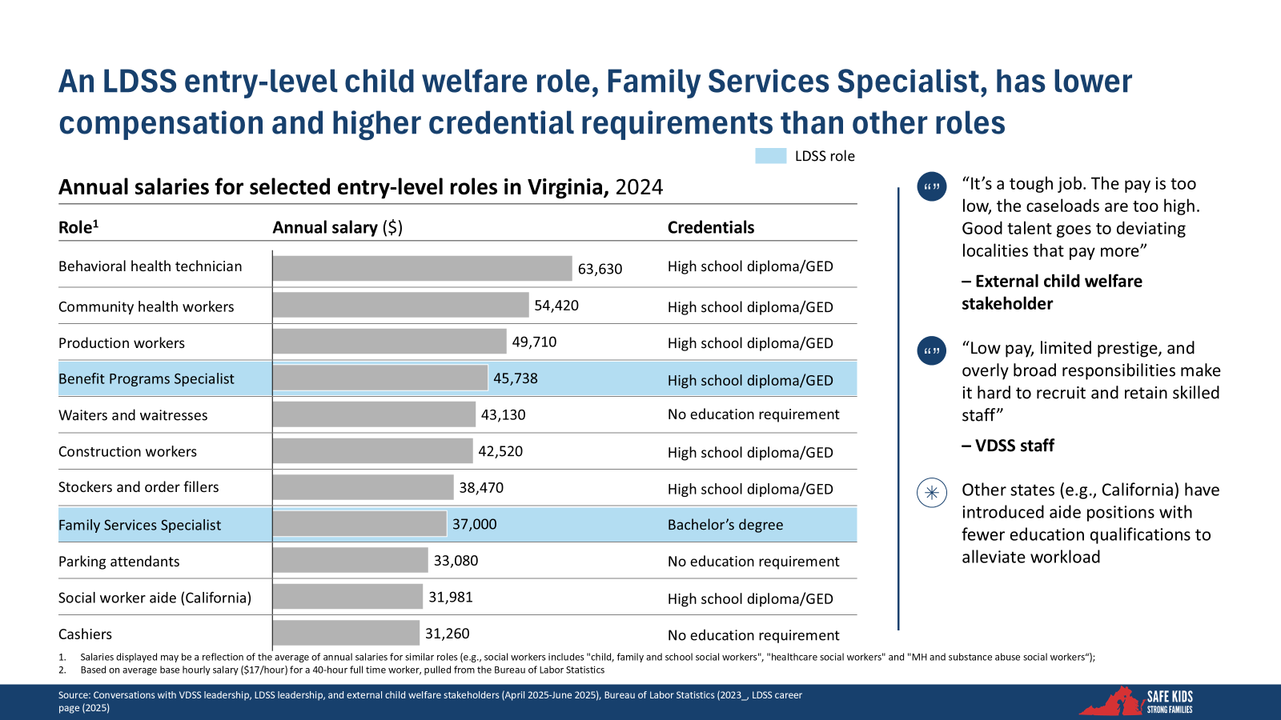
The data underscores a significant misalignment between the required credentials and compensation for Family Services Specialists (FSS), an entry-level role critical to child welfare service delivery. Despite requiring a bachelor’s degree, the role pays less than many other entry-level roles that require no formal education. This pay disparity, coupled with heavy caseloads and emotionally taxing work, contributes to persistent recruitment and retention difficulties across the state.
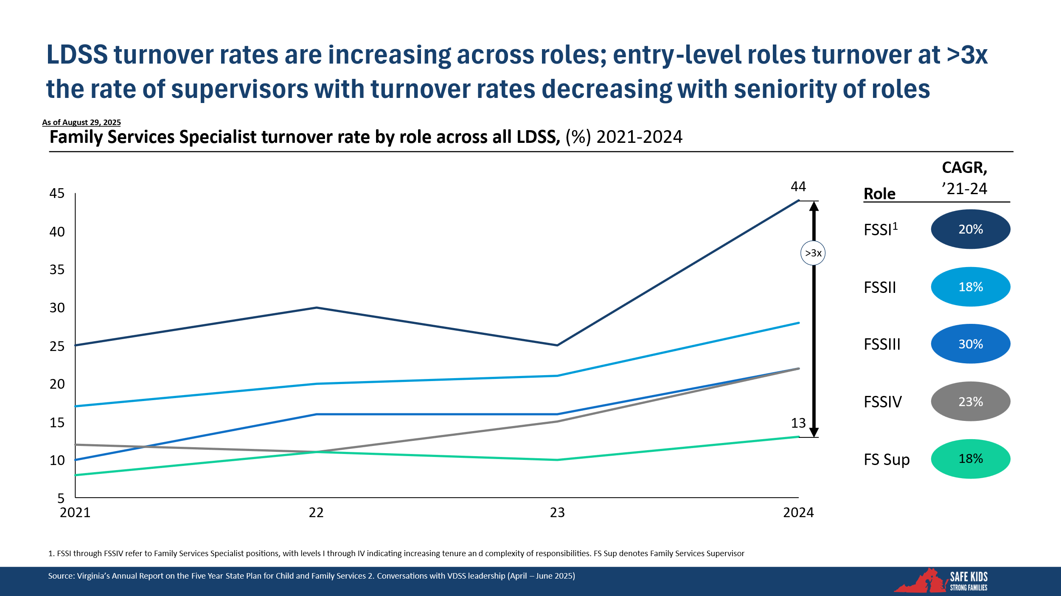
In addition, attrition of FSS roles is a critical issue. In particular, entry-level FSS have a turnover rate of 44%. This means that nearly half of all newly hired FSSs will leave within their first year at an LDSS. Attrition rates are also increasing across all roles.
In addition, LDSS with high vacancy rates tend to have lower outcome metrics (e.g., screen-in rate, timeliness of first contact with potential victim, and percent of high/very high opened to in-home services). This data reflects the necessity of the workforce and the impact of high vacancy rates on child welfare outcomes.
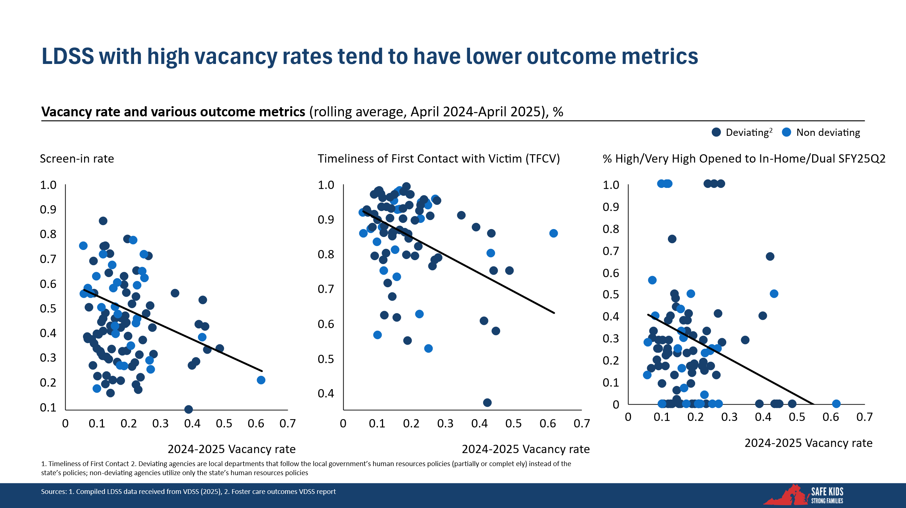
Virginia’s child welfare stakeholders informed the development of specific workforce-strengthening initiatives. Organized around five distinct topics, the initiatives include: compensation, recruitment, professional development, staff retention, and employee experience. These initiatives intend to both stabilize the current workforce and build a more sustainable employee pipeline. They include piloting new recruiting pathways through high schools and community colleges, offering broader educational stipends, enhancing professional development infrastructure, incorporating staff voice in agency decision making, and introducing programs to address early tenure attrition. The initiatives reflect lessons learned from peer states and are meant to align with ongoing efforts within VDSS to modernize the workforce and improve service delivery outcomes for the Commonwealth’s children and families.
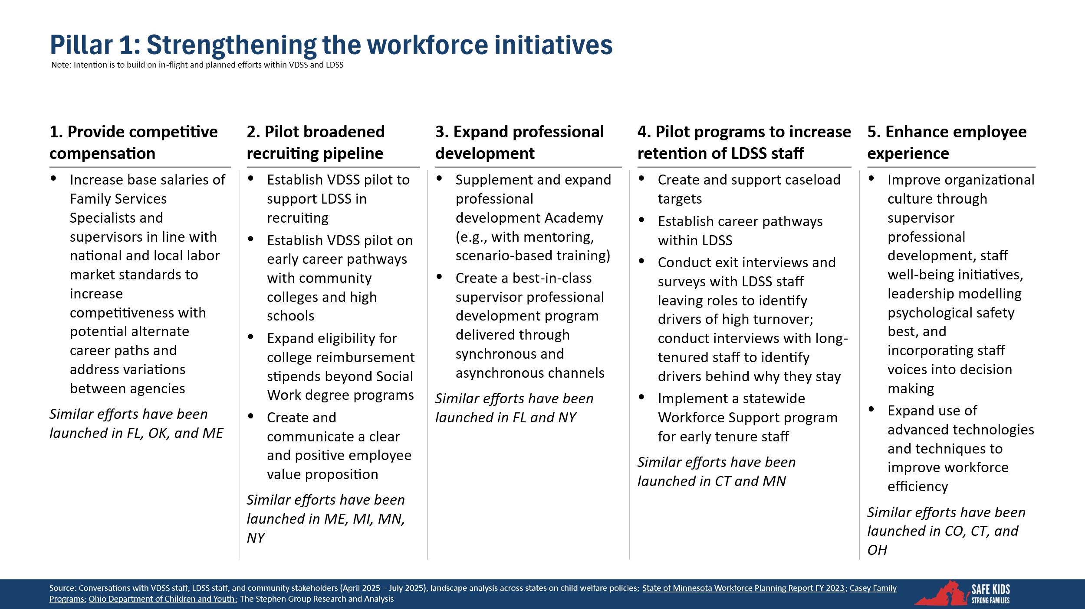

Pillar 2: Child Protective Services (Safety)
A Child Protective Services (CPS) system that consistently applies policies and processes ensures that every child in Virginia, regardless of their zip code, receives the same level of protection, care, and opportunity. Across Virginia, the engagement and timeliness of CPS interventions vary by locality, creating an uneven safety net where a child’s access to critical services depends more on geography than need.

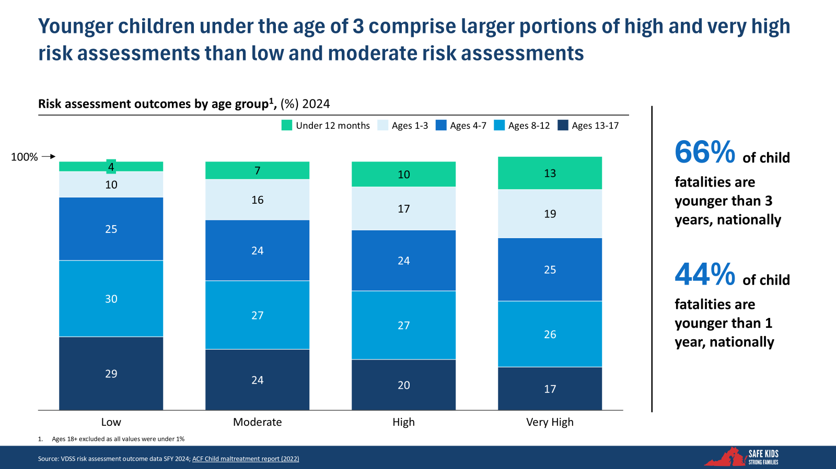
Within Virginia’s CPS system, there is a disproportionate vulnerability of young children, particularly those under the age of three. The data aligns with national trends, indicating that children under three account for a significant majority of child fatalities, underscoring the importance of age-sensitive risk screening and resource prioritization. In addition, there is variation in the timeliness of core CPS functions (e.g., first contact with potential victims, safety assessments, and risk assessments).
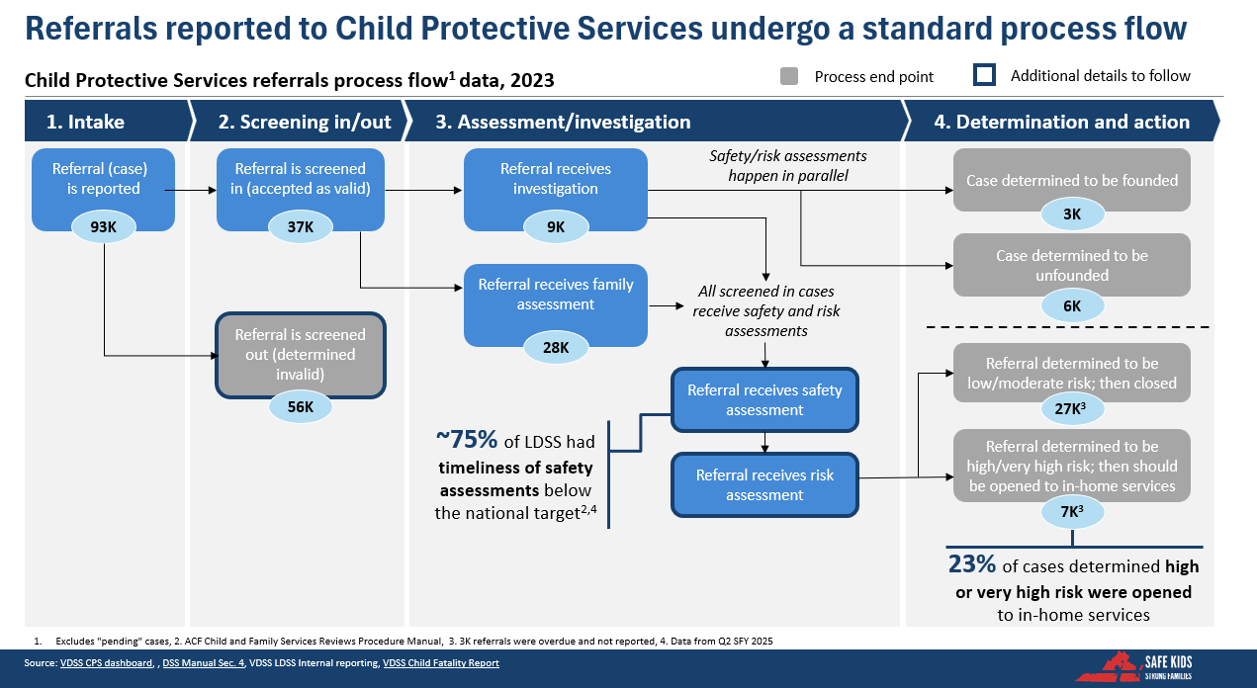
The Child Protective Services (CPS) process in Virginia follows a four-stage standard workflow from intake to case resolution. In 2023, approximately 93,000 referrals were received. Of these, approximately 40% were screened in for further action, while the remaining 60% were screened out as invalid. Notably, national data indicates that a portion of child fatalities involved at least one prior screened-out referral, highlighting potential gaps.
Among screened-in cases, referrals are routed either to an investigation or a family assessment. Regardless of path, all accepted cases undergo parallel safety and risk assessments. However, timeliness remains a concern. Nearly 75% of local departments had safety assessment timelines that fell below national benchmarks.
In the final phase of the process, outcomes are categorized by risk and determination. A small portion of cases were substantiated (“founded”), while most were either closed as unfounded or determined to be low or moderate risk.
Only 23% of cases identified as high or very high risk were opened to receive in-home services. This raises important questions about how to better engage high-risk families in these services and expand access to support for those most at risk.
Together with stakeholders, Pillar 2 initiatives aim to strengthen the consistency, responsiveness, and equity of Virginia’s Child Protective Services (CPS) system. In 2023, more than 75% of high and very high-risk child welfare cases were not opened. As a result, affected children and families did not receive any services and interventions, potentially leaving children exposed to harm. The Commonwealth needs to revise and consistently implement guidance to ensure timely services for families, especially those with young children. The initiatives are designed to address persistent gaps in intake, and inconsistently applied assessment and decision-making processes, particularly for the highest-risk populations.
There are four key areas of focus: first, centralizing referral intake and validity determinations under VDSS to reduce inconsistency across local agencies and improve the reliability of early case decisions. Second, prioritizing the safety of children under age three, who are most vulnerable to harm, by calling for more immediate and structured responses to referrals involving this age group, as well as better coordination with health care systems that are often engaged in treatment. Third, proposing the use of advanced analytics to support initial risk assessments and supplement human judgment with consistent data inputs. Finally, the initiatives aim to strengthen accountability by implementing a data-informed monitoring system to identify and support underperforming localities.
Collectively, these initiatives reflect a shift toward more standardized, proactive, and technology-enabled child protection practices, while building on lessons from other states.
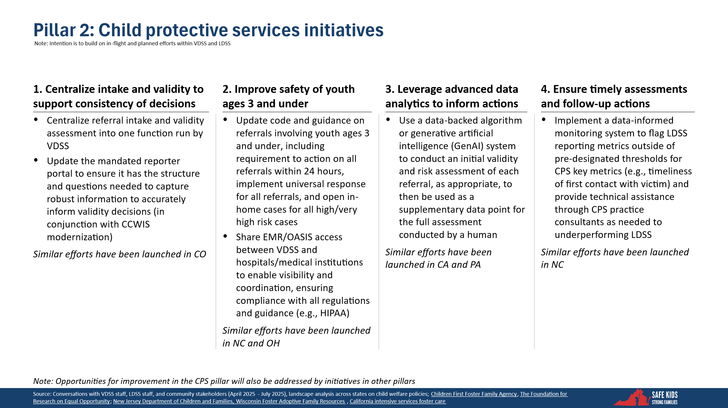

Pillar 3: Permanency for Youth
Permanency has been the primary focus of Virginia’s child welfare system for the past 15 years. Achieving permanency, particularly for youth in foster care, has profound, lifelong implications for stability, identity, and well-being. There are challenges facing Virginia, including elevated rates of youth aging out of care, lower-than-average reunification rates, and an increasing reliance on congregate care placements. VDSS notes, “Children with complex needs are most prevalent in congregate care and we know that successfully getting a child returned back into a family home out of a residential setting, is very difficult.” The Commonwealth’s trends indicate systemic gaps in family-based placement options, decreased utilization of transition supports for older youth, and a need to shift the system toward stable, supportive, and family-centered outcomes for all children and youth in care.
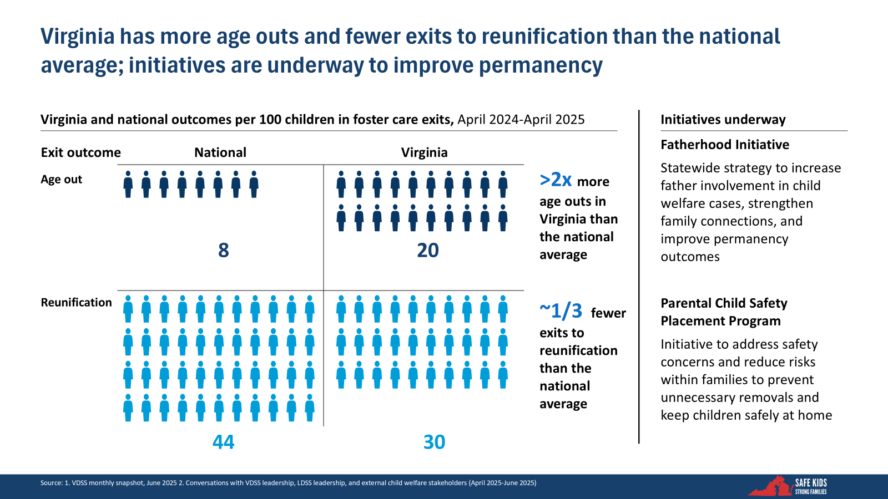
- Virginia’s permanency outcomes for children in foster care differ from national outcomes. Compared to national averages, Virginia sees more than double the rate of youth aging out of care and approximately one-third fewer exits to reunification. These figures signal a critical gap in achieving stable, family-based outcomes and suggest missed opportunities for timely intervention and support. In response, Virginia is pursuing targeted strategies such as the Fatherhood Initiative, to strengthen familial bonds and developing strong relationships with their children.
and promote reunification and the Parental Child Safety Placement Program, which focuses on keeping children safely at home by addressing intra-family risks early. These initiatives represent steps Virginia is taking to begin reversing the trend and ensure more children exit care through lasting, family-centered pathways.
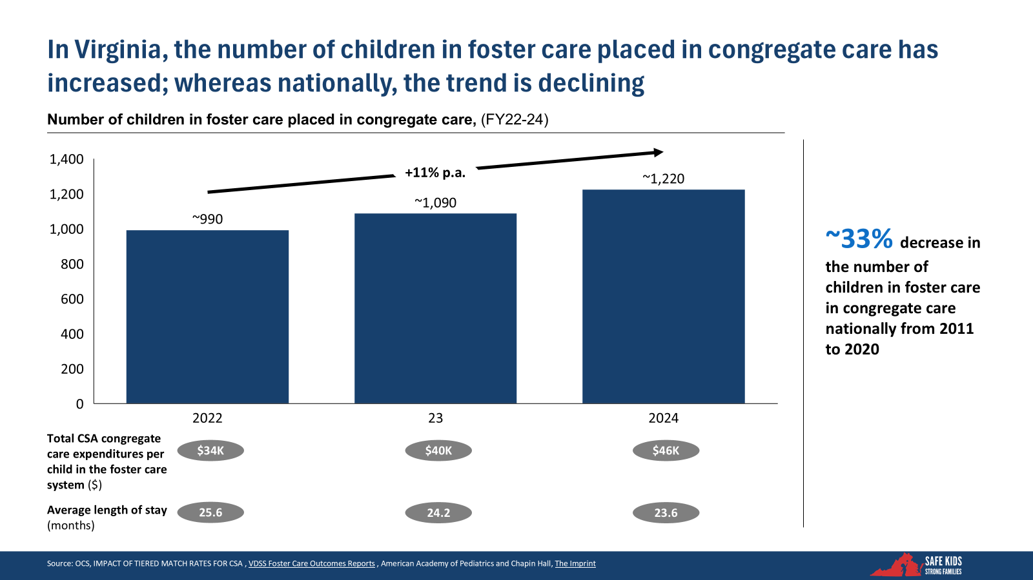
There is a contrasting trend between Virginia and the national landscape. While congregate care placements have declined nationally, they have increased in Virginia, rising at an average rate of 11% annually from 2022 to 2024. The trend reflects systemic gaps in community-based placement options, particularly for youth with complex behavioral or developmental needs. It underscores the urgent need for stronger, family-based alternatives, early and consistent access to behavioral health services, and cross-system coordination. The data make clear that reversing this trajectory requires deliberate investment in designing appropriate behavioral health services, strengthening provider capacity, and building the infrastructure needed to support high-acuity youth outside institutional settings.
A multi-pronged strategy is essential to enhance permanency outcomes by minimizing unnecessary congregate care, bolstering support for foster and guardianship families, improving transitions for youth aging out of care, and facilitating safer, faster family reunifications. Key reforms include expanding wraparound supports for families caring for high-needs youth, offering stipends and services to retain foster families, and establishing consistent transition support for older youth exiting care. Together, these initiatives aim to reduce reliance on institutional care, improve family stability, and ensure that every young person exits care with a permanent and supportive plan in place.
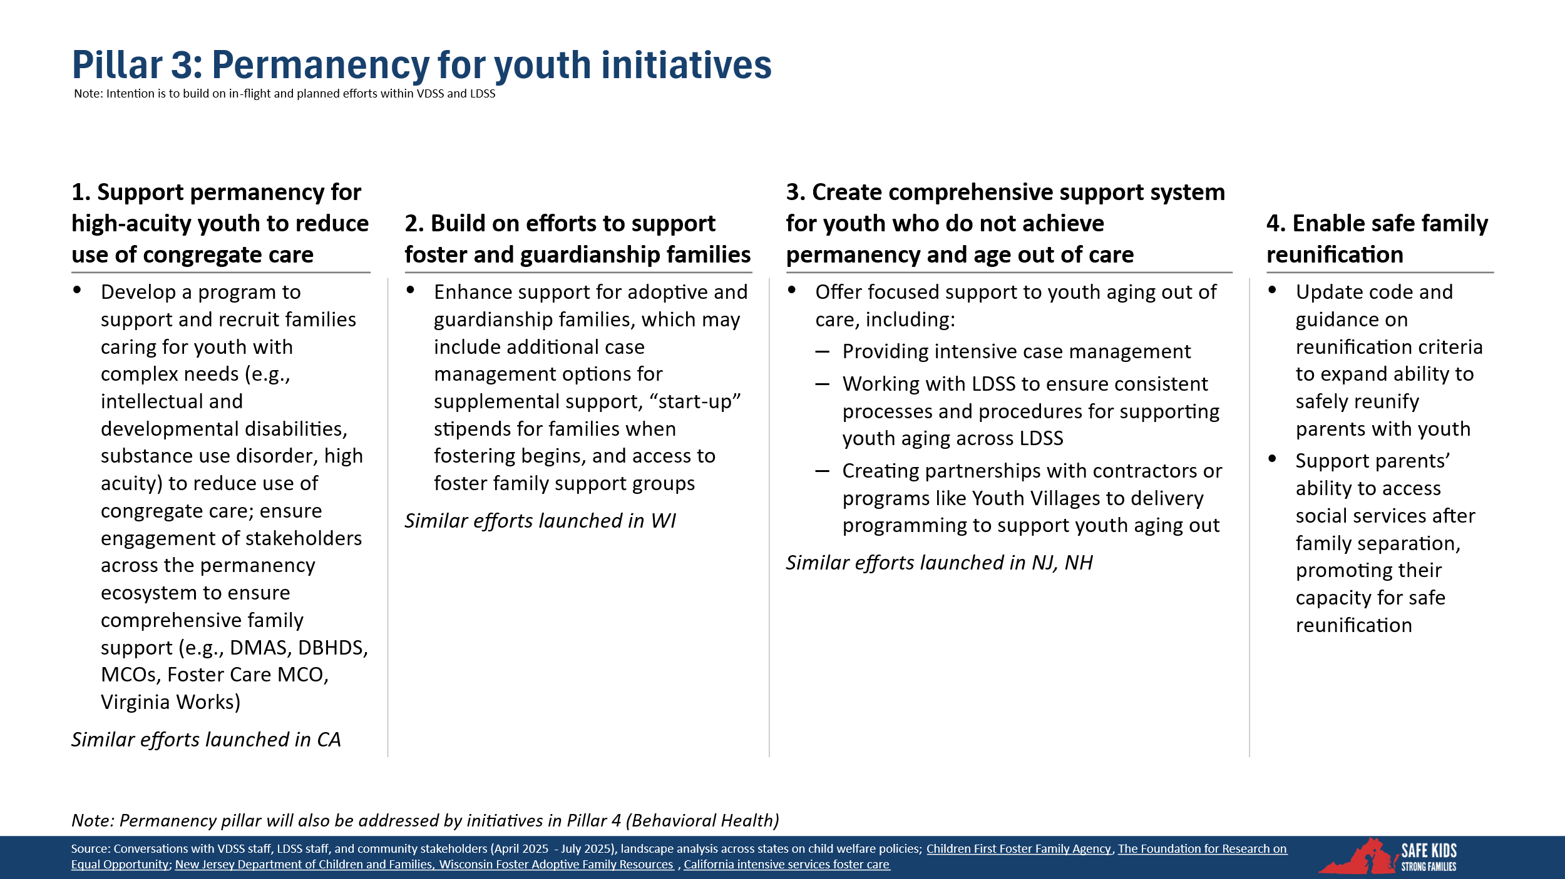

Pillar 4: Behavioral Health
Access to behavioral health services is essential to ensuring the stability and well-being of children and families involved in or at risk of entering Virginia’s child welfare system. Behavioral health care should serve as a critical component of preventive child welfare strategy, not only as a crisis response mechanism. Early and sustained access to behavioral health services can help families remain safely together. For children already involved in foster care, continued access to appropriate behavioral health treatment is vital to their emotional development, permanency outcomes, and long-term resilience. A system that integrates behavioral health supports across the child welfare continuum, from early identification to sustained engagement, is foundational to improving outcomes and reducing the need for higher-intensity interventions.
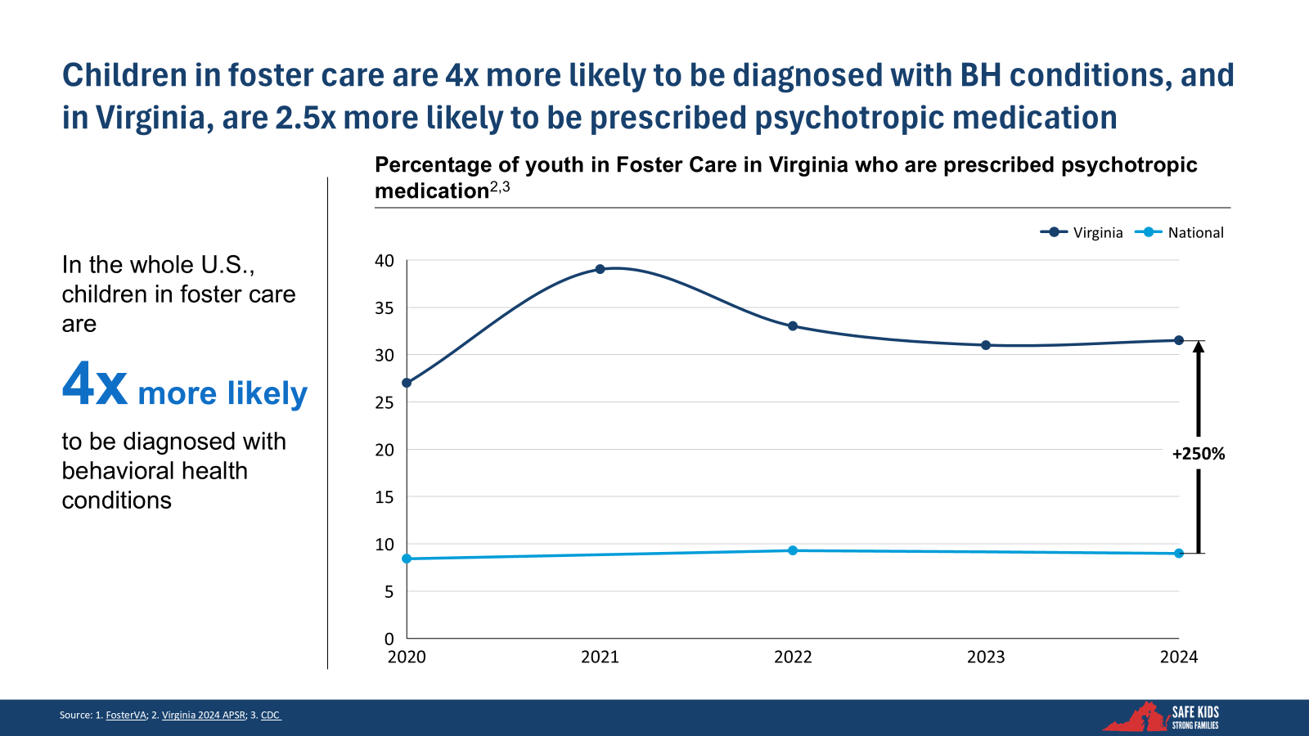
Children in the foster care system carry a disproportionate behavioral health burden as underscored by national data that indicates children in foster care are four times more likely than their peers to be diagnosed with behavioral health conditions. Focusing specifically on Virginia, in 2024, children in foster care were prescribed psychotropic medication 2.5 times more than the national average among their peers. While some of this increase reflects the severity and complexity of needs among child welfare involved children and youth, it also raises important questions about the access and availability of non-pharmacological interventions, trauma-informed care pathways, and consistent oversight of medication practices. The data underscores the importance of strengthening behavioral health service access and coordination for foster children and youth.
Working with stakeholders, VDSS has designed initiatives to enhance access to behavioral health services across the child welfare continuum. These strategies prioritize early and equitable access to behavioral health supports, improved coordination with Medicaid and foster care specialty plans, and targeted support for families affected by substance use disorders (SUD). There is a key emphasis on prevention and crisis response, ensuring that trauma screening, outreach, and services are offered at critical intervention points. The proposals also call for expanded training and consultation through the Virginia Mental Health Access Program (VMAP) to equip child welfare staff and prescribers with tools to respond to the needs of trauma-impacted youth. Collectively, these efforts aim to reduce system fragmentation, improve youth outcomes, and promote preventive and more appropriate, family-centered behavioral health interventions within the child welfare system.
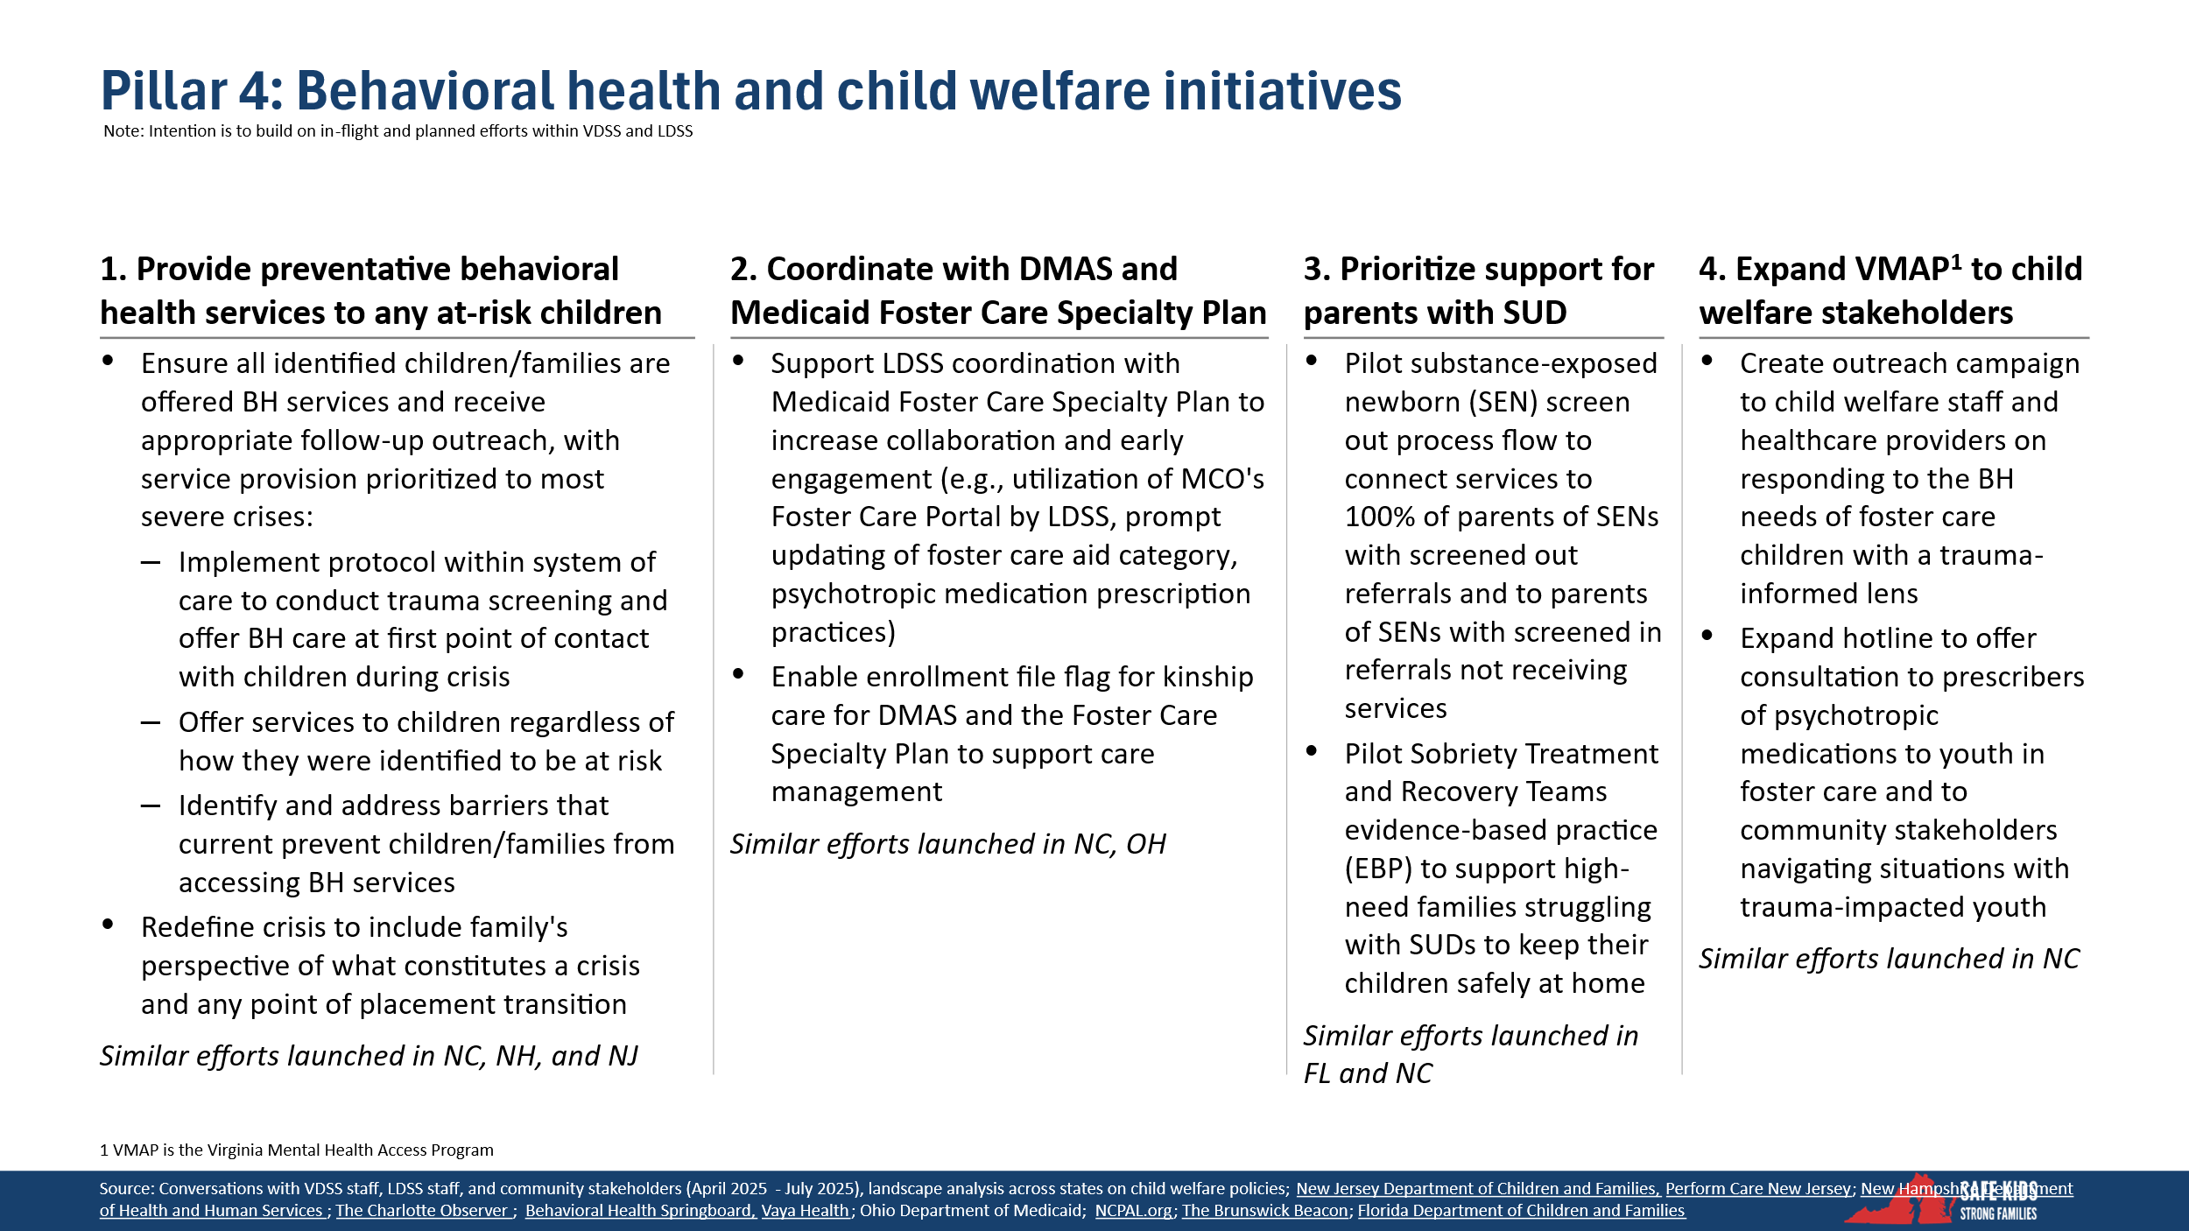

Pillar 5: Prevention and Family Preservation
A strong prevention infrastructure is the foundation of a responsive child welfare system. Virginia has made progress in expanding access to Evidence-Based Practices (EBPs) under its prevention plan, though overall utilization of Title IV-E prevention funding remains limited. Capturing more of the available Title IV-E prevention funding would bolster the Commonwealth’s ability to stabilize families early and avoid deeper system involvement. Even where EBPs have expanded, frontline staff report persistent service gaps, particularly in rural and underserved areas. Aligning Title IV-E prevention services with those covered by Medicaid would help leverage and expand existing prevention resources, strengthening the provider base and enhancing the system’s capacity to keep children safe.
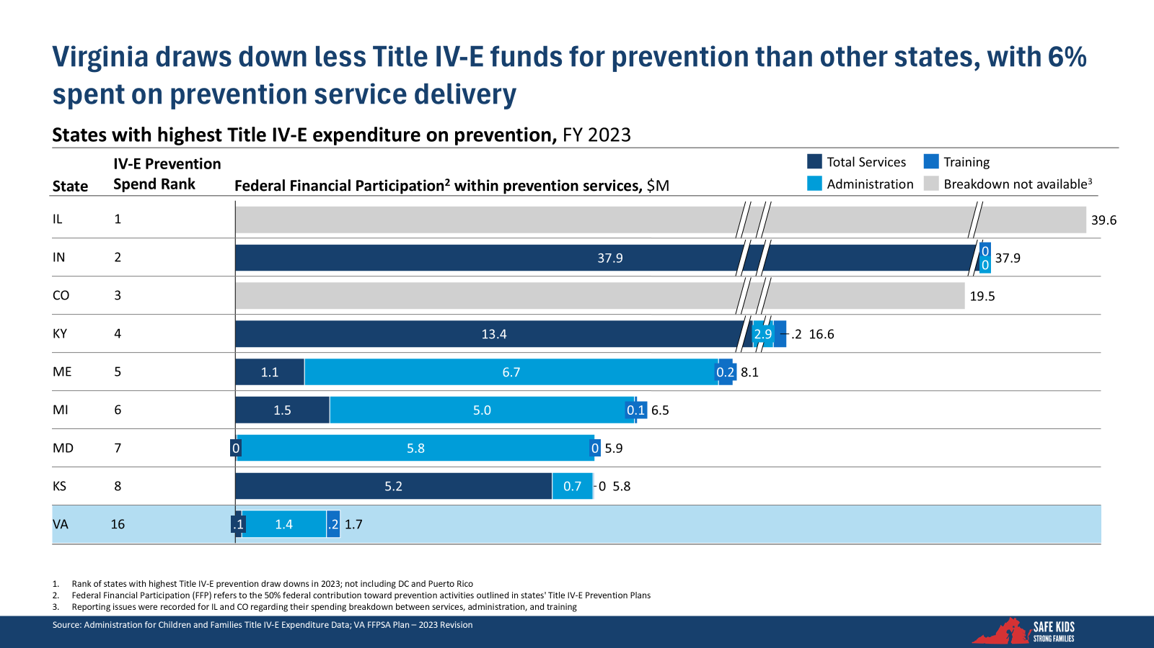
Despite national momentum around prevention-first approaches in child welfare, Virginia ranks low in federal prevention spending, allocating only a small share of its drawn down funds directly to service delivery. This suggests that Virginia could be missing opportunities to leverage available federal funding for early intervention and family stabilization services. The limited investment in preventive services not only reduces the state’s capacity to safely keep families together but may also lead to higher downstream costs through increased foster care placements and deeper system involvement.

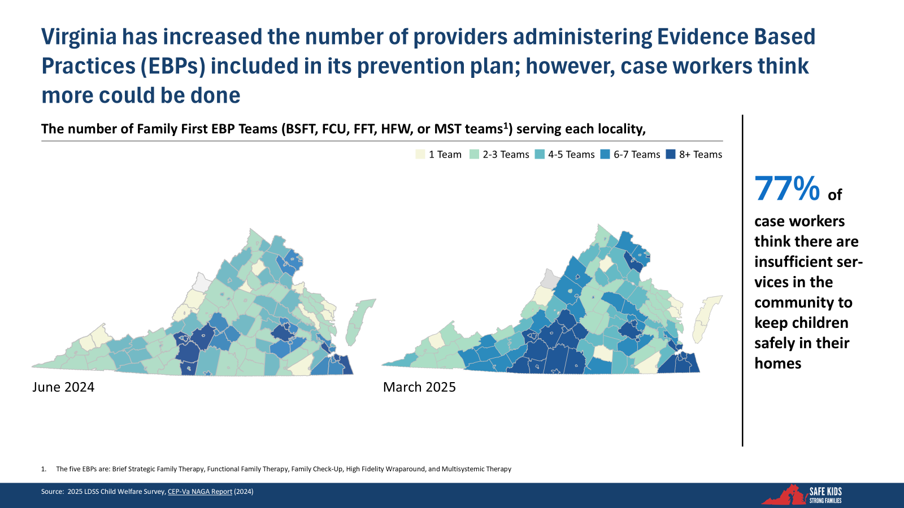
Virginia has made progress in building and supporting a network of evidence-based providers. Between June 2024 and March 2025, the number of teams delivering these services has increased, demonstrating a growing commitment to high-quality, community-based interventions. However, despite these gains, frontline feedback reveals that availability across the Commonwealth remains insufficient. More than three-quarters of LDSS caseworkers report that services are still too limited to keep children safely at home.
Evidence-based providers rely on a steady stream of referrals to sustain high-quality services. Without consistent referrals, they cannot generate the revenue needed to cover the costs of their highly skilled teams, putting at risk the very provider network Virginia has worked so hard to develop. This disconnect between policy intent and service availability underscores the need to strengthen Community Pathways using federal IV-E funding. Such funding could provide a 50/50 funding match for preventive services, including for children and families who have not yet entered into the child welfare system.
Virginia stakeholders have come together to offer a comprehensive framework to expand Virginia’s prevention infrastructure by creating localized, community-based pathways to support families. The first priority is to establish multidisciplinary prevention teams within each planning district, equipping them to guide families to appropriate services in collaboration with schools, medical providers, and faith-based organizations. This model emphasizes early identification of needs, especially for high-risk children under age three, and aims to standardize service coordination across regions through shared tools and protocols.
The second initiative focuses on increasing equitable access to prevention services across all localities. By refining eligibility definitions and encouraging each LDSS to offer both primary and secondary services, the initiative aims to fill current geographic gaps in service availability. Finally, the third priority seeks to maximize the state’s use of federal Title IV-E prevention funds by supporting required assessments, streamlining administrative processes, and incentivizing higher-performing local agencies. Together, these proposals aim to institutionalize early intervention, reduce unnecessary removals, and strengthen family preservation efforts statewide through scalable, community-driven solutions.
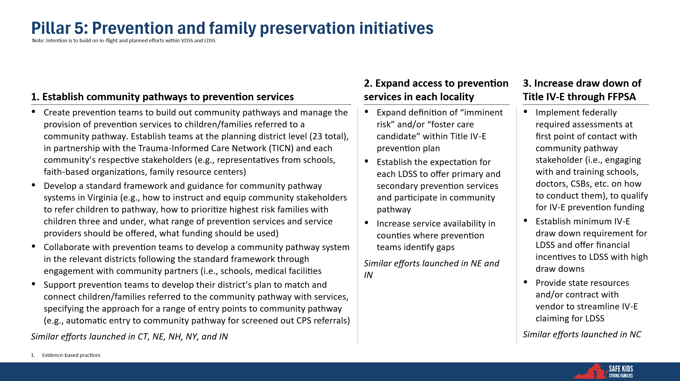

Pillar 6: Modernization of Oversight and Infrastructure
Modernizing oversight and infrastructure is essential to building a more accountable, efficient, and equitable child welfare system. VDSS recognizes that meaningful reform requires more than front-line practice changes; it also demands strong governance structures, improved data systems, and better alignment between state and local responsibilities. By addressing longstanding challenges in organizational structure, workforce capacity, and transparency, a more responsive and data-informed system can support better outcomes for children and families statewide.
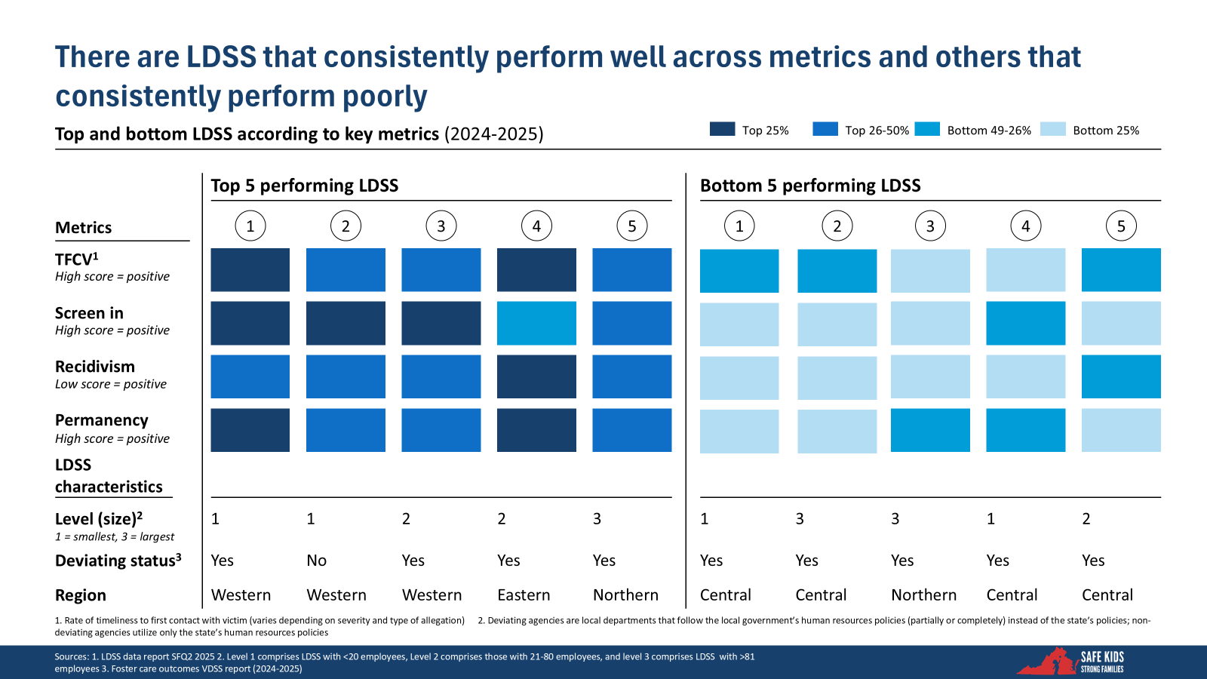
There are variations in performance among LDSS in Virginia. Some agencies consistently excel (e.g., top 25% relative to other LDSS) across critical child welfare metrics such as timeliness, screening, recidivism, and permanency. Other LDSS perform worse (e.g., bottom 25% relative to other LDSS) across the same child welfare metrics. Notably, strong-performing LDSS are found in small, mid-sized, and large agencies, have both deviating and non-deviating status, and are located across regions.
In addition, there is variation across LDSS in practice standards. Some LDSS screen in approximately 10% of referrals, whereas others screen-in approximately 85% of referrals. Furthermore, the screen-in rates are not correlated to outcome metrics (e.g., timeliness of first contact with a potential victim).
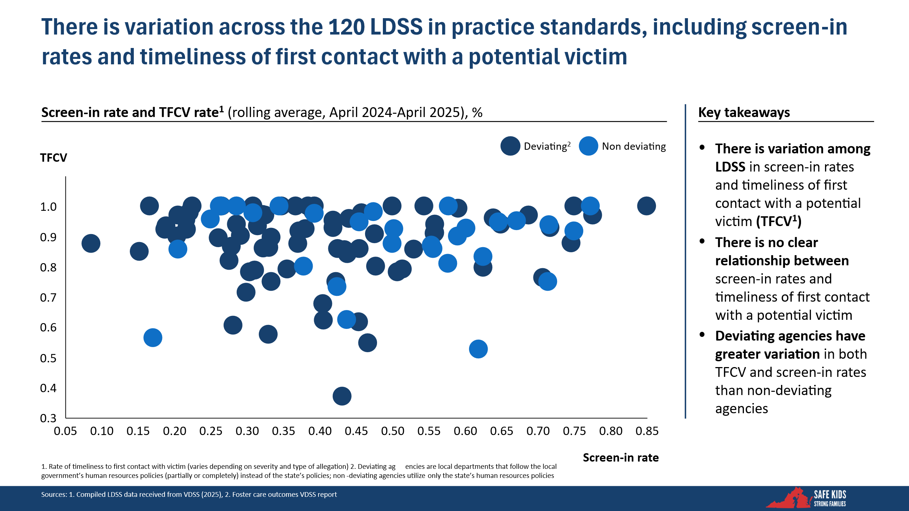
These patterns highlight the variation across LDSS and the need for consistent performance expectations, better alignment between local and state practices, and tailored support to struggling agencies to reduce geographic inequities in outcomes.
Furthermore, VDSS oversees more local agencies in total (120 LDSS) and by region (an average of 24 LDSS per region) than any other state-supervised, locally administered child welfare system. Virginia has nearly two times the total number of local departments than the average state-supervised, locally administered system (66 on average). VDSS has five regional offices. Each regional office oversees approximately 24 LDSS. This 1:24 ratio of region to local departments is much high than other regional oversight structures (which range from approximately 2 – 17 local departments).
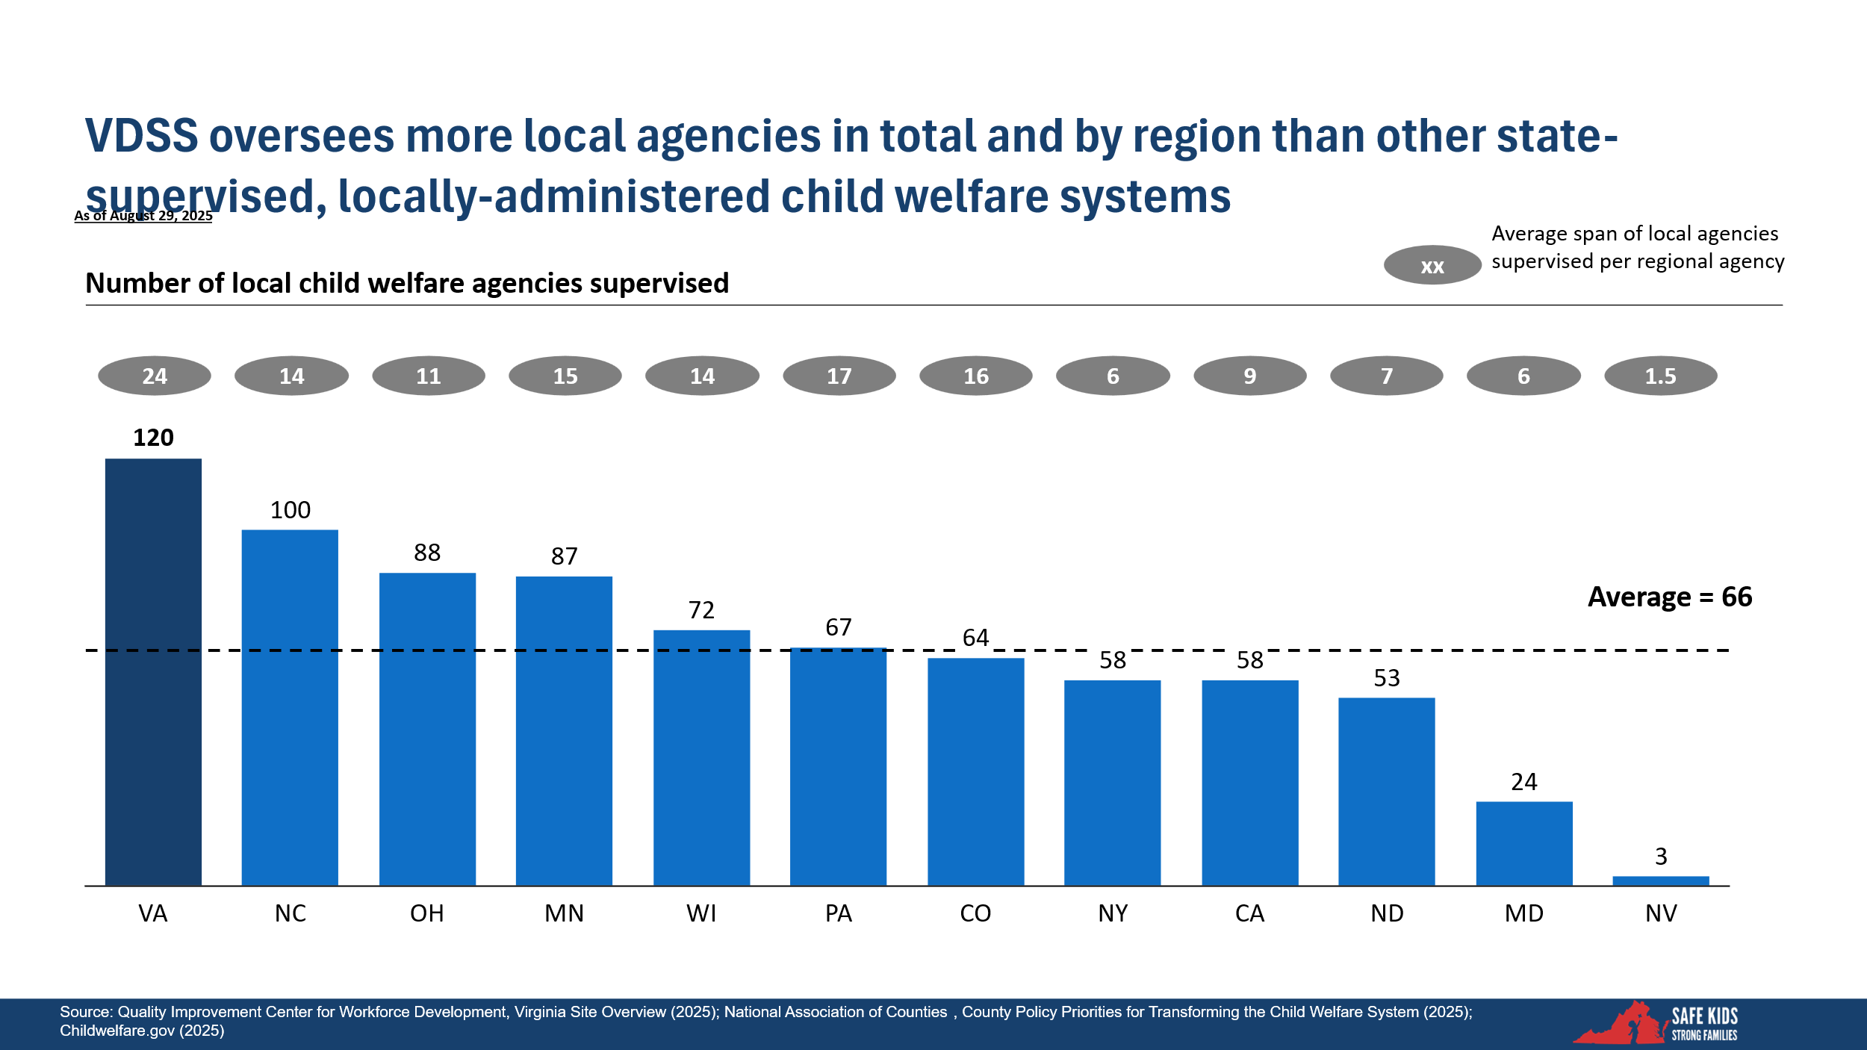

In addition, Virginia has fewer structural tools to manage LDSS performance than other states. Peer states have implemented a range of state-to-local enforcement mechanisms, including financial incentives, formal accountability agreements, and centralized programming supports. Virginia relies primarily on data and performance management, with limited enforceability. Access to more robust oversight tools would strengthen VDSS’s ability to measure consistent quality across jurisdictions, especially in a locally administered system. The findings suggest that Virginia could benefit from adopting mechanisms used in other state-supervised systems to drive performance improvement and enforce standards across all LDSS.
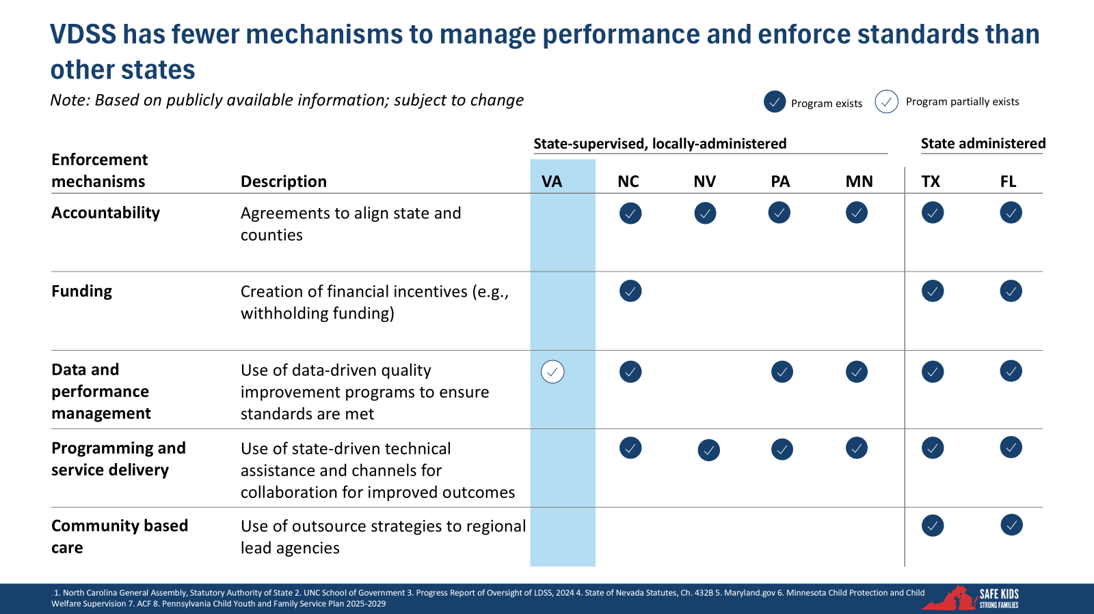
Various technical and operational barriers hinder Virginia’s ability to manage its child welfare system using data-informed decision-making. Key challenges include inconsistent data-entry practices, particularly within the OASIS system, and a lack of clear state-level guidance, resulting in process variation across local agencies. In addition, many workers have trouble navigating the system, and many agencies face added barriers such as limited access to shared information technology (IT) infrastructure and communications. Underlying these issues is outdated infrastructure that fails to provide complete or accurate workforce data and lacks the integration needed to support coordinated case management. Without system modernization, Virginia’s ability to track, evaluate, and improve child welfare outcomes remains constrained.
Stakeholders have collaborated to develop a comprehensive strategy to modernize Virginia’s child welfare oversight and infrastructure. The foundation is an established statewide accountability framework, anchored in formal agreements between VDSS and LDSS outlining performance expectations and data-driven continuous quality improvement (CQI). This is complemented by a plan to modernize the state’s data system, improving functionality and flexibility to support consistent performance monitoring and service coordination.
The proposed initiatives also seek to clarify governance roles and improve communication between state and regional offices, addressing longstanding fragmentation and inefficiencies. Recognizing the challenge of inconsistent local capacity, the initiatives include the use of a standardized case management process to better assign responsibility and propose expanding state support for local case management functions. Using a nationally recognized practice like the Three-Branch toolkit ensures collaboration across the three branches of government working together for the benefit of children and families. Finally, the initiatives include a commitment to improving transparency in cases involving abuse or fatalities—marking a step toward building public trust and accountability. Together, these proposals aim to strengthen system oversight, streamline operations, and create the foundation for a more effective and equitable child welfare system across the Commonwealth.
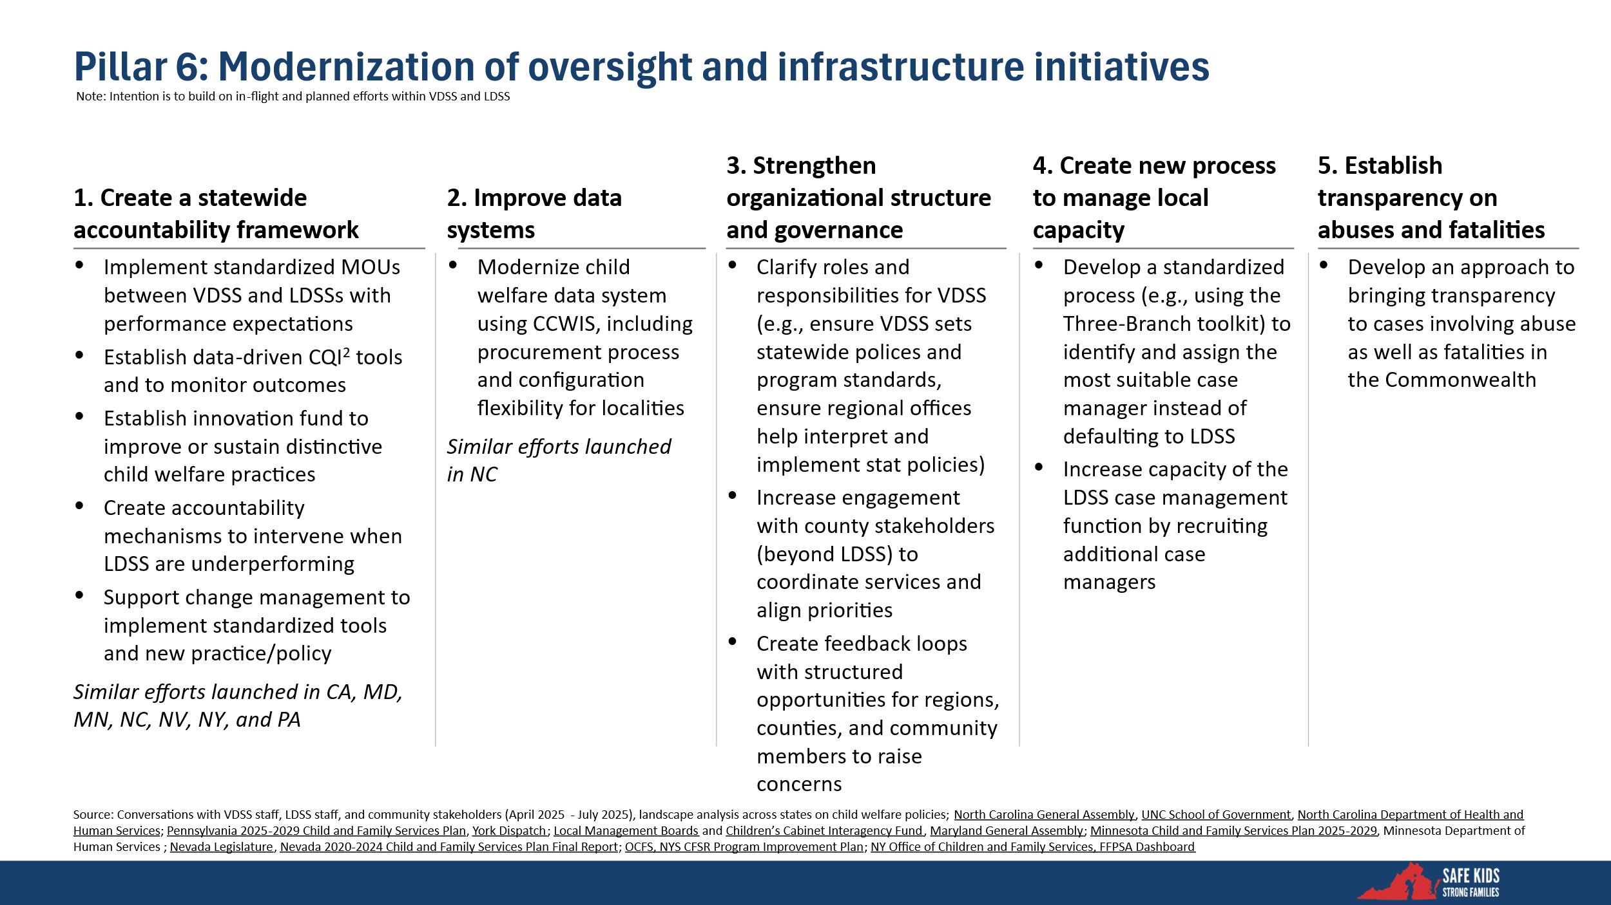

Summary of Pillars and Initiatives
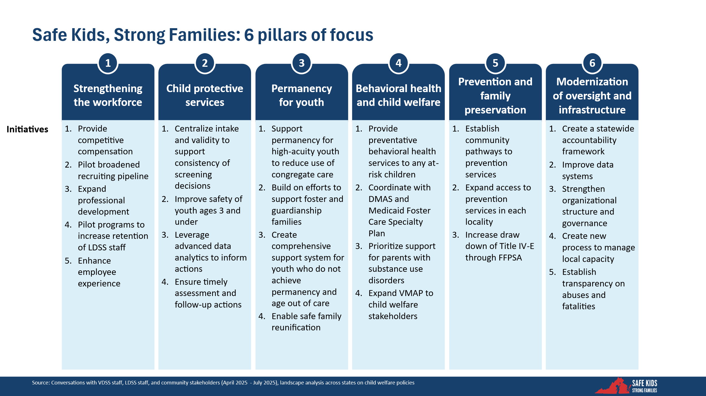

Initiatives Prioritized by Steering Committee
Within this framework, the Safe Kids, Strong Families Steering Committee identified three priority initiatives for immediate action. These initiatives aim to stabilize the workforce, increase consistency and accuracy in service access, and strengthen system accountability. Prioritized initiatives include:

- Create a statewide accountability framework
- Centralize intake and validity to support consistency of Child Protective Services screening decisions
- Provide competitive compensation

#1: Create a Statewide Accountability Framework (Pillar 6: Modernization of Oversight and Infrastructure)

A modern, performance-driven child welfare system requires shared standards, transparent data, and mechanisms for continuous quality improvement. In a decentralized system like Virginia’s, where 120 local departments operate semi-independently, maintaining consistent quality across the state is challenging.

Currently, the absence of a formal statewide performance framework has made it difficult to:
- Track performance across LDSS offices in a fair and transparent way
- Quickly identify and respond to gaps in safety, permanency, or well-being outcomes
- Target support to localities facing structural or workforce challenges

While many local agencies are delivering under challenging conditions, others are struggling to meet baseline expectations, often without clear feedback or support. The result is varied outcomes for children and families, and growing frustration among LDSS leaders who want clearer guidance, better tools, and more constructive collaboration with the state. At the same time, the lack of formal accountability mechanisms creates risk.

What the Accountability Framework Brings
This initiative would establish a structured, transparent performance management system grounded in partnership and continuous improvement. It includes:
- Standardized Memorandums of Understanding (MOUs) between VDSS and each LDSS outlining roles, expectations, and performance benchmarks
- Data dashboards and progress reports to give LDSS leaders timely, actionable insights
- Targeted support and escalation pathways — including technical assistance, temporary staffing augmentation, and contracted interventions if needed

The accountability framework is designed to create clarity, alignment, and a shared commitment to quality. It supports a consistent standard of care for families across Virginia, regardless of geography. For LDSS directors, it will provide predictable expectations, greater visibility into their agency’s performance, and stronger support from the state when challenges arise.

Actions
- Establish MOUs between VDSS and LDSS outlining expectations.
- Develop and launch dashboards and performance monitoring tools.
- Create intervention supports, including staffing augmentation and contracted services, for underperforming localities.

#2: Centralize Intake and Screening of Child Welfare Referrals (Pillar 2: Child Protective Services)
Currently, practices for Child Protective Services vary across LDSS offices, leading to inconsistent screening decisions and inequities in how children and families enter the system. A centralized model for intake and screening will ensure more reliable and data-informed decision-making.

Benefits of Centralized Intake
In Virginia’s current state-supervised, locally administered model, intake and screening practices are different across jurisdictions. While local flexibility has its advantages, it has also led to significant inconsistency in how child welfare referrals are screened, validated, and acted upon. This variation results in inequitable service access for families and puts children’s safety at risk.

Further, intake screening is a high-stakes decision point, determining whether a concern receives further assessment or no formal response. Errors in this process, whether through under-screening or over-screening, can have serious consequences, including delayed interventions, inappropriate investigations, or missed opportunities for prevention.
LDSS staff have shared concerns, including a lack of consistency in training and interpretation of guidance, screening fatigue and pressure due to high call volumes and workforce shortages, and limited data to evaluate the accuracy or effectiveness of screening decisions.

This initiative proposes a statewide centralized intake system with:
- Dedicated, centralized, staff trained in uniform standards and protocols
- Integration of data analytics and decision support tools (including AI) to improve consistency and overall decision-making
- The ability to route valid referrals efficiently to the appropriate LDSS for follow-up

This model would reduce the burden on local offices while promoting statewide equity, accuracy, and transparency. LDSS offices will continue to play a central role in responding to screened-in reports, but the initial screening process will be more consistent, more supported, and less vulnerable to error.

Actions
- Launch a statewide intake and validity system using standardized protocols and trained centralized staff.
- Reduce variability and enhance accuracy in risk screening, increasing public confidence and child safety.

#3: Provide Competitive Compensation (Pillar 1: Strengthening the Workforce)
Virginia’s child welfare system is facing a workforce crisis driven by chronic underpayment and unsustainable staff turnover. FSS and supervisors are paid significantly less than peers in comparable public service roles, despite demanding qualifications and emotionally intensive work. This leaves agencies unable to compete for talent and strains service delivery statewide.

Benefits of Competitive Compensation
To attract and retain the skilled professionals essential to frontline service delivery, Virginia must modernize its compensation structure. Workforce vacancies and turnover are among the most destabilizing forces in the system today.

- Reduces Turnover and Stabilizes Caseloads: Higher pay improves retention, reducing service disruptions for vulnerable children and families.
- Boosts Recruitment: Competitive salaries attract new talent, including candidates from fields like law enforcement, veterans’ services, and social work.
- Supports Leadership Stability: Increased compensation for supervisors promotes internal advancement and strengthens frontline oversight.

Actions
- Raise base salaries for FFSs and supervisors in line with labor market benchmarks.
- Improve job competitiveness and staff retention by aligning child welfare careers with other public service professions.

